**Consulting Engagement Scope Statement**

**Group 26**

**Link**

[Group 26 Scope Statement.docx](https://georgiancollege-my.sharepoint.com/:w:/r/personal/200535448_student_georgianc_on_ca/Documents/Team%2026/Group%2026%20Scope%20Statement.docx?d=w38f378210ec940c98433fc83ac24ef4a&csf=1&web=1&e=jjskwO)

**Team Members:**

Jasmeen Kaur

Shivank Giri

Yanish Shahi

Table of Content

1. **Project Background ........................................................................................... 3**
2. **Scope of the Project ........................................................................................... 3**
3. **Project Objectives .............................................................................................. 3**
4. **Project Deliverables ........................................................................................... 4**
5. **RACI Chart ......................................................................................................... 5**
6. **Reference........................................................................................................... 5**
7. **Meeting Cadence ................................................................................................ 5**
8. **Gantt Chart ........................................................................................................ 6**
9. **Reports .............................................................................................................. 7**

**ACME AI Integration Project Scope Statement**

1. **Project Background:**

ACME Corporation, one of the world's leading suppliers of sales skill development, intends to include AI into its 3,000 student programs offered across five campuses. This improves the effectiveness of sales method training. Investors are concerned about how much AI can do without jeopardizing the programs' integrity and authenticity. Program experts also fear that AI will replace them and take away the originality from the content. Under the guidance of the CEO, Fred Begena, the project chooses AI solutions with great care to enhance learning while preserving the integrity of ACME's training. The implementation is scheduled for September 2026, with a focus on creating a scalable solution to meet educational and business goals.

1. **Scope of the Project:**

The scope of this project is to integrate AI technologies into ACME Corporation’s sales training programs to enhance the learning experience and improve customer service for 3,000 students across five campuses and 50 programs. The project will focus on:

In Scope:

* Examine current training programs to find areas where AI might be improved.
* Decide which AI technologies best meet the training goals of ACME Corporation.
* Analyze expenditures and keep spending inside the budgetary constraints.

Out of Scope:

* Deployment of AI technologies into the training programs.
* Development of custom AI tools or software solutions.
* Post-implementation maintenance and support for AI systems.

1. **Project Objectives**

This project aims at enhancing learning and customer service by embedding AI technologies into the ongoing training programs of the ACME Corporation, reaching out to five campus locations with 3,000 students in 50 programs. It will be an effort aimed at identifying and implementing the most suitable AI technologies that have the potential to bring tremendous enhancement in sales effectiveness within training, greatly minimizing learner challenges on tests and exams, while managing well within available budgets, meanwhile reassuring the investor regarding the impact of AI on course quality and authenticity.

Identify and implement those AI technologies that best fit the objectives of ACME's training while developing a more effective and accessible method of learning sales tactics.  
  
Select appropriate AI solutions with careful consideration to avoid investor concerns about course quality, authenticity, and originality.  
  
Conduct an effective cost analysis and keep the project within budget by tracking all expenses.

1. **Project Deliverables**

To ensure comprehensive planning, execution, and reporting, the ACME AI Integration Project will be carried out in phases, each with unique deliverables. The following are the project's main deliverables:

* Phase 1: Capstone Consulting Engagement Schedule

A thorough project plan that describes the timetable, important dates, dependencies between tasks, and distribution of resources throughout the duration of the consulting engagement. To track the project and reporting progress, this timeline will act as the standard.

* Phase 2: Consulting Engagement Scope Statement

A thorough document that describes the project's objectives, deliverables, inclusions, exclusions, and general methodology. This declaration will make the project's parameters and goals clearer.

* Phase 3: Client Proposed Solution and Implementation Schedule Artifact

A suggested AI integration solution that is customized to ACME's operational requirements and includes an implementation timeline that details the delivery of each solution component at each time. This document guarantees that the project's execution plan and the client's expectations are in line.

* Phase 4: Client Project Implementation Risk Analysis Artifact

A comprehensive risk analysis document that identifies hazards, including resource-related, operational, and technological risks, during project implementation. Additionally, the paper will suggest ways to lessen the possibility that these risks will have an influence on the project's success.

* Phase 5: Proposed Solution Budget and Consulting Engagement Cost to Date Artifact

A budget for the AI integration solution that includes estimated expenses for every stage of the project's development. To provide fiscal management transparency, this artifact will also include a summary of the consulting engagement expenditures incurred thus far.

* Phase 6: Proposed Solution and Implementation Portfolio Report

A thorough report that compiles the system architecture, workflows, schedules, and testing procedures for the suggested AI solution and its execution. The documentation required for the solution's successful deployment will be included in this portfolio, which the customer can use as a guide.

* Phase 7: Final Buy-In Proposed Solution Plan

A comprehensive project summary that includes the budget, risk analysis, implementation schedule, and AI solution. Prior to final implementation, this deliverable will be shown to ACME stakeholders to gain their support and agreement on the suggested solution.

1. **RACI Chart**

By ensuring that everyone on the team is aware of their responsibilities within the project, the RACI chart facilitates effective task management and execution. This division guarantees that every task is finished within the specified responsibilities and responsibility structure and facilitates communication.

|  |  |  |  |  |
| --- | --- | --- | --- | --- |
| **Task** | **Responsible (R)** | **Accountable (A)** | **Consulted (C)** | **Informed (I)** |
| Develop Work Breakdown Structure (WBS) | Jasmeen | Project Manager | Shivank | ACME Team |
| Define Project Schedule | Yanish | Project Manager | Jasmeen | ACME Team |
| Allocate Budget and Resources | Shivank | Project Manager | Jasmeen | ACME Team |
| Perform Testing & QA | Yanish | Project Manager | Jasmeen | ACME Team |
| Risk Assessment | Shivank | Project Manager | Yanish | ACME Team |

**Team Time Commitment:**

* Jasmeen Kaur: 2 hours/week at $50/hour.
* Yanish Shahi: 2 hours/week at $50/hour.
* Shivank Giri: 2 hours/week at $50/hour.

1. **Reference**

* Lauren Good (2024,April 19).What is a RACI Matrix?. <https://project-management.com/understanding-responsibility-assignment-matrix-raci-matrix/>

1. **Meeting Cadence**

Weekly team meetings will be held every week via the MS Project Team Channel. Jasmeen Kaur will be responsible for scheduling and managing the meetings. The meetings will be conducted using the Microsoft Teams platform, and meeting minutes will be recorded and shared via the channel.

The MS Project Team Channel will serve as the central hub for:

* File sharing.
* Task updates.
* Video conferencing.

1. **Gantt Chart**

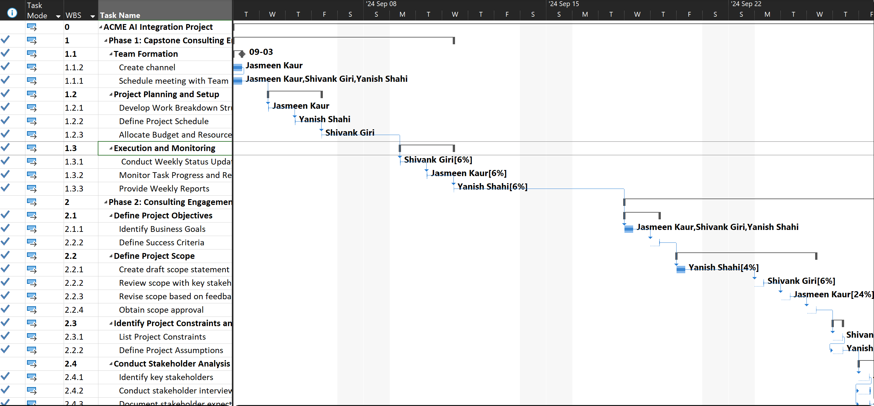

1. **Reports:**

**Dashboard Reports**

* Cost Overview Report

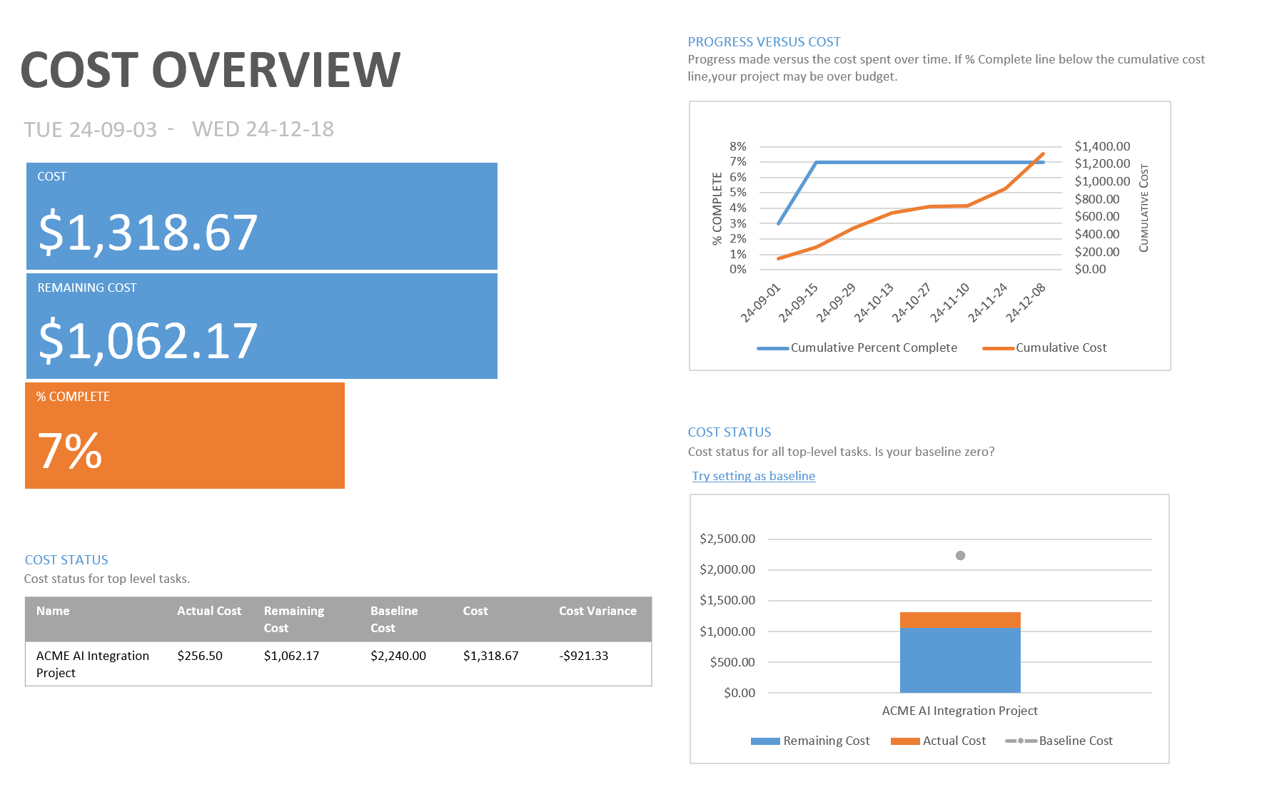

* Upcoming Tasks Report

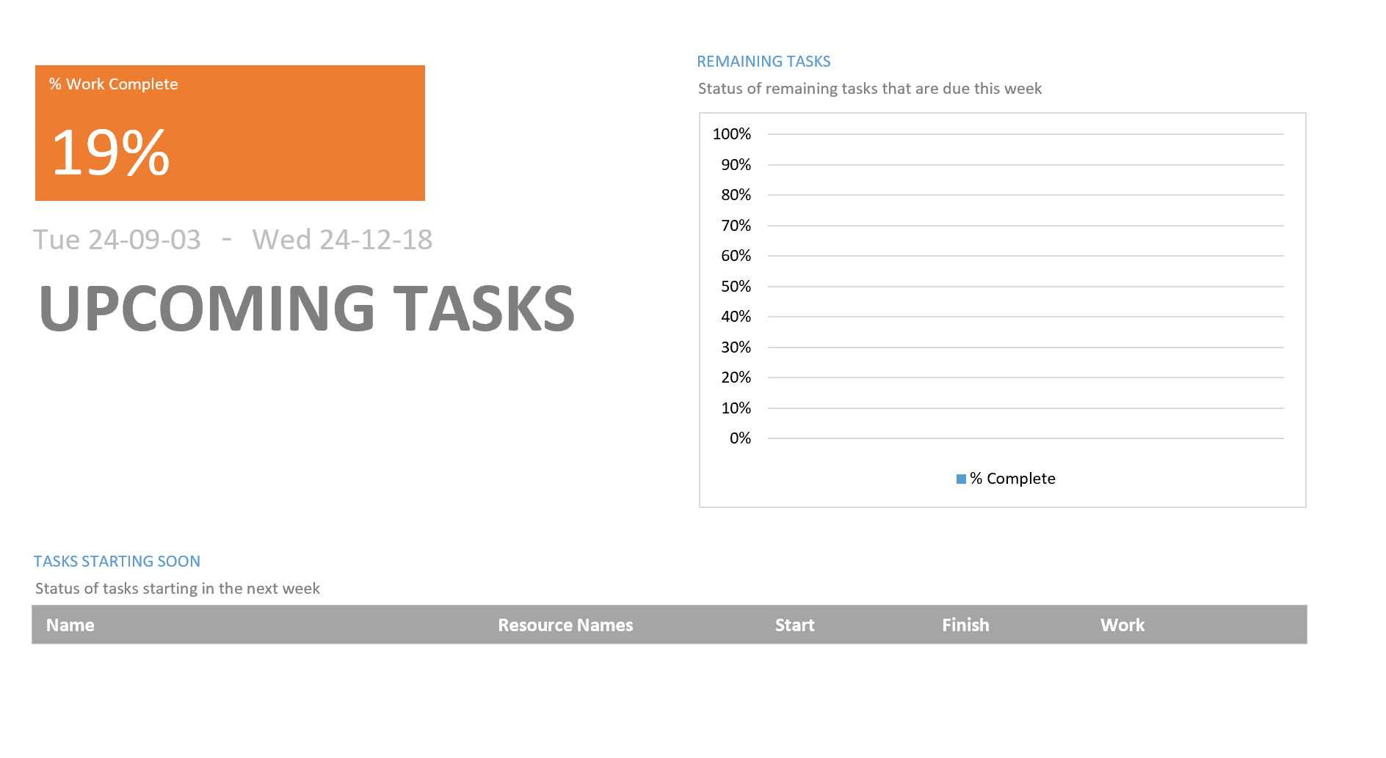

**Resouces Report**

* Overallocated Resources Report

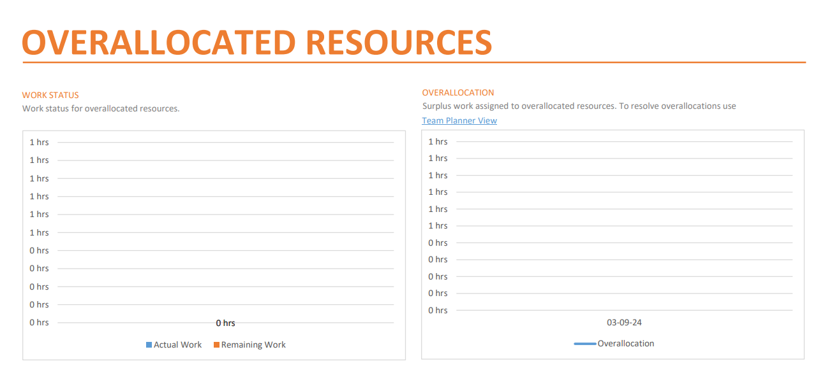

* Resource Overview Report

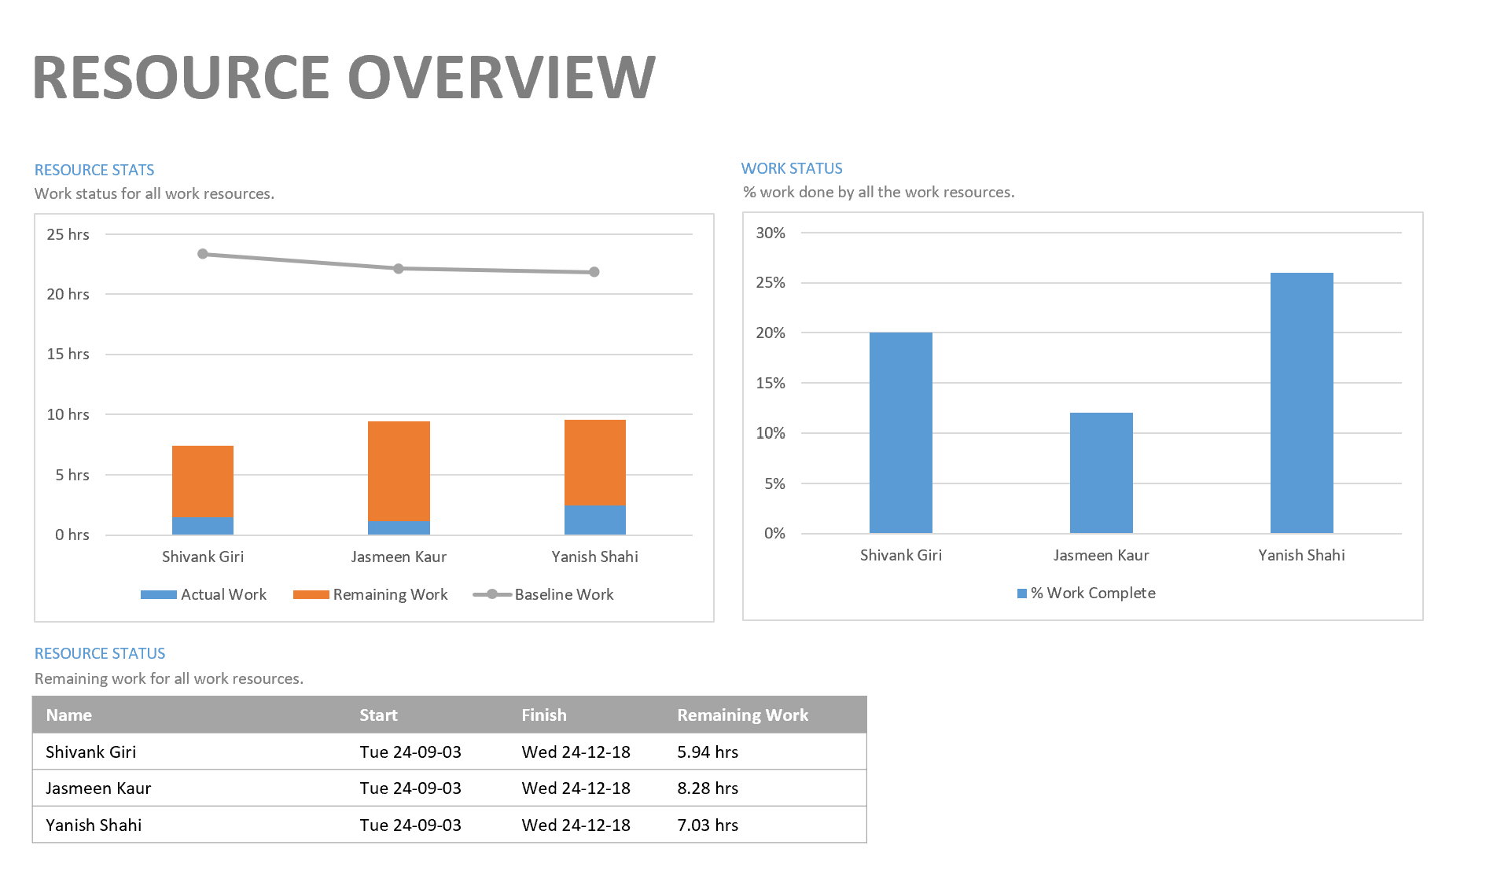

* Resource Cost Overview Report

